Using AI, Being a Great Programmer & How the Web Works
Class 2 notes. How to use AI without losing your edge, what actually makes a programmer great, and the journey a web request takes.
Class: 2 · Format: Lecture + live demo + 2 quizzes + doubt session
Why this matters: AI can now type code as fast as you can describe it. That is exactly why this class matters. If prompting is all you have, you are easy to replace. Your edge is understanding the design, owning the outcome, and knowing how the system underneath actually works.

What you should be able to do after this
- Tell apart prompting like a vibe coder and building like an engineer
- Use AI in two disciplined modes, as a sensei and as a function generator
- Move from being a distiller to being an owner who runs and documents experiments
- Say what makes a programmer great once syntax is cheap
- Trace a web request from start to finish across client, DNS, server and database

What's inside
1. Prompting isn't programming
2. Mode 1: AI as your sensei
3. From distiller to owner
4. Mode 2: AI as a function generator
5. Leverage & the Golden Rule
6. What makes a programmer great now
7. How the web works: the players
8. The request-response cycle & HTTP

1. Prompting isn't programming
In one line: Anyone can type "build me an app". Your value is understanding every line that comes back.
Key points
- Live demo: "build me a tic-tac-toe app" produces a working toy in seconds.
- So here is the real question. What makes you a programmer and not a sales guy who learned to prompt?
- A vibe coder describes the what and hopes it works. For a toy, it does.
- It falls apart the moment the app gets real, breaks, or needs to scale.
- AI closed the gap on typing code. It did not close the gap on engineering judgment.
- That gap is your job: the design, and every line of the output.
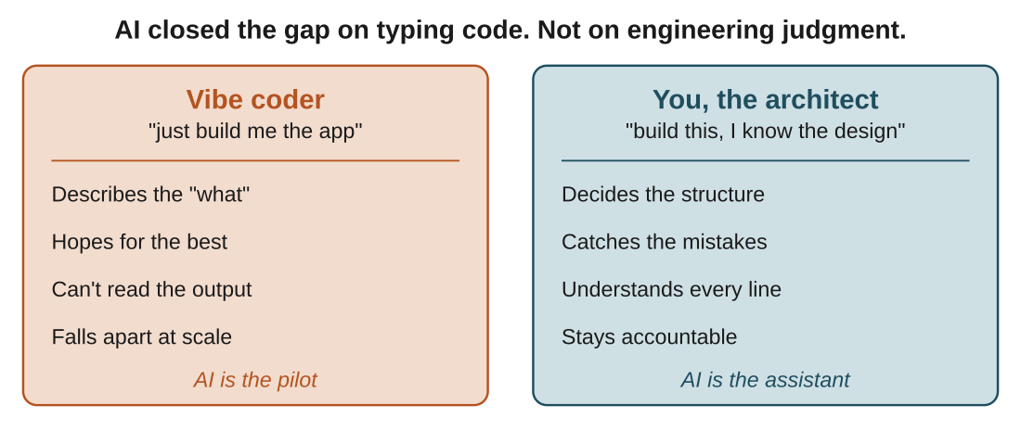
Figure 1: same tool, two people. The difference isn't the prompt. It's who understands and owns the output.
In the real world: A designer or non-coder ships the tic-tac-toe demo and it works. Ask them to add online multiplayer or fix a race condition and they are stuck, because they can't read a single line of what was generated. The app built itself in nine seconds. That is the scary part, not the impressive part.
Watch out: The cleaner way to say it: you are the architect, AI is the assistant. The assistant types fast and never tires, but it does not get to be the pilot.

2. Mode 1: AI as your sensei
In one line: Tell the AI to teach you, not to hand you the answer.
Think of it like: A sensei doesn't fight your battles. They set the drill, correct your form, and make you do the rep, so the skill ends up in you rather than in them.
Key points
- The prompt: "You are my sensei. Teach and guide me, but never just hand me the answer. Push me to figure it out."
- Then go down the rabbit hole. Ask anything, even the things that feel stupid.
- AI never judges you and never tires of your questions.
- Every "but why?" takes you one layer deeper, and that depth is where understanding forms.
- Be respectful to the AI. Not because it has feelings, but because small habits shape the kind of engineer you become. Saying please to a chatbot costs you nothing and quietly keeps you a decent human.
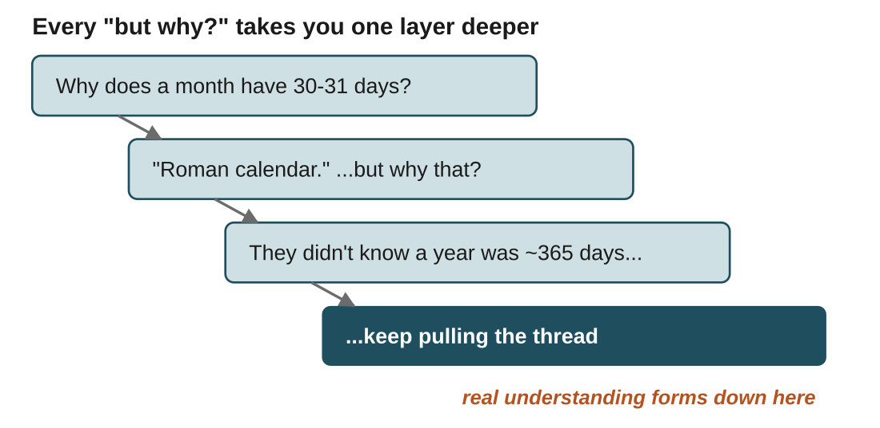
Figure 2: the rabbit hole. Each follow-up question drops you a level, and the understanding lives at the bottom, not the top.
In the real world: "Why does a month have 30 or 31 days?" You get "the Roman calendar". You push back: "but they didn't know a year was about 365 days, so how did they land on that?" It offers another thread, and you keep pulling. Five questions later you understand something most people never checked.

3. From distiller to owner
In one line: AI now does the distilling in seconds, so your value moves to owning outcomes rather than gathering information. The years you were going to spend reading 15 tabs just got refunded.
Key points
- Earlier, when you hit a problem, you read 10 sources and 15 articles and synthesized it all by hand. Doing that over and over is how seniority compounded.
- That manual distillation was the moat. AI just removed it.
- The new answer is to stop being only a distiller and become an owner.
- Combine a product lens with the ability to design experiments that make the business faster or better.
- Treat AI like a playground for building and testing ideas.
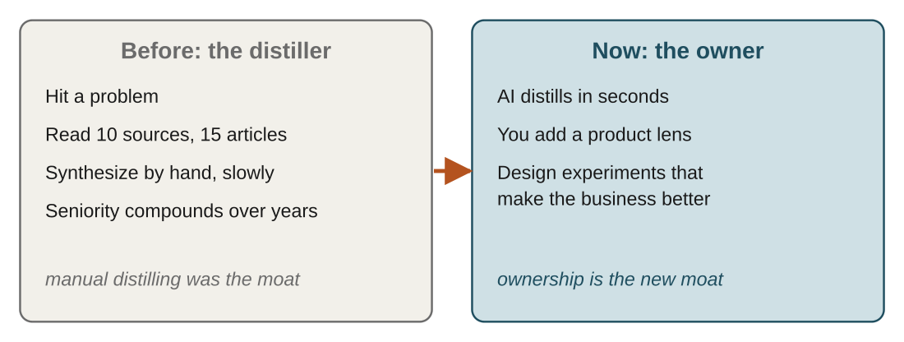
Figure 3: the moat moved. What used to take days of reading is now nearly free, so the value is in what you do with it.
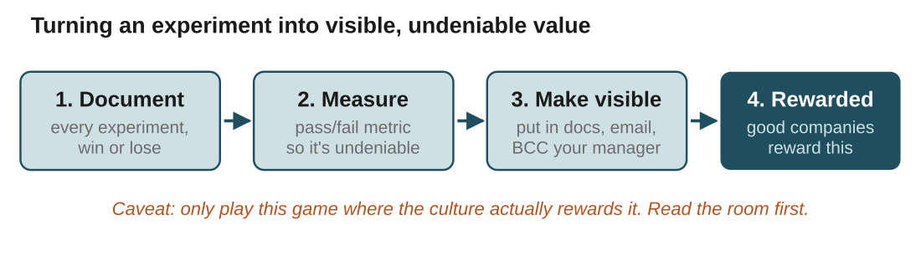
Figure 4: how to actually capture the value of an experiment. Skip any step and the win stops being yours.
In the real world: A learner sat with a different team at lunch, solved a problem for them using AI, and ran a quick training for them. That is ownership and leverage in action. The work got seen, credited, and was repeatable.
Watch out: Only play the visibility game where the culture actually rewards it. Read the room first. In some teams, BCC'ing the founder reads as showing off rather than ownership.

4. Mode 2: AI as a function generator
In one line: Don't ask AI for one giant program. Ask it for small, DRY functions with one job each.
Think of it like: It is how you already think in OOP, with small functions inside classes each doing one thing. You are just letting AI do the typing.
Key points
- Every function is callable and testable on its own. Ask AI for a sample input and expected output for each.
- Debugging becomes trivial, because it is now function-level debugging and you know exactly where it broke.
- You stay in control. You can direct AI to fix only the one function that needs it.
- It cuts token cost, because you are not regenerating a whole file to change five lines.
- This is the difference between "I engineered my program with AI" and "AI wrote my program".
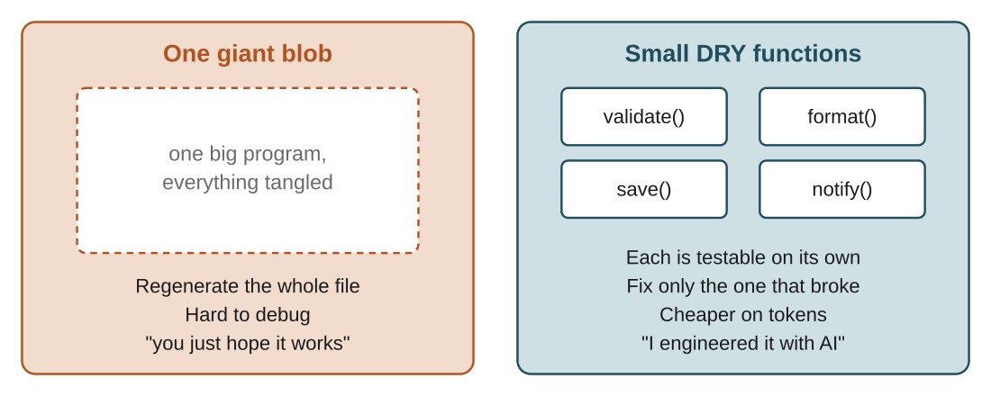
Figure 5: same feature, two ways to ask for it. The right side is the one you can debug, test, and defend.
In the real world: Building a signup flow, ask for validateEmail(), hashPassword(), saveUser() and sendWelcome() as separate functions. When the welcome email fails, you fix sendWelcome() on its own instead of regenerating the whole file and hoping. One giant blob of code is fun right up until it breaks at 2am and you have no idea which of its 400 lines is lying to you.

5. Leverage & the Golden Rule
In one line: Don't rebuild what already exists, and never hand AI the controls.
Key points
- Keep an eye on open-source projects. The thing you are struggling to build often already exists, maintained and ready to use.
- Reinventing it by hand is not a badge of honour. It is wasted time.
- The Golden Rule. Use AI to learn and break down concepts, research and distill, unblock you when you are stuck, and analyze your style so you get better.
- But never make it the pilot. You direct, and it assists.
- AI is powerful only if you can imagine the possibilities. Without that imagination it is just a chatbot.
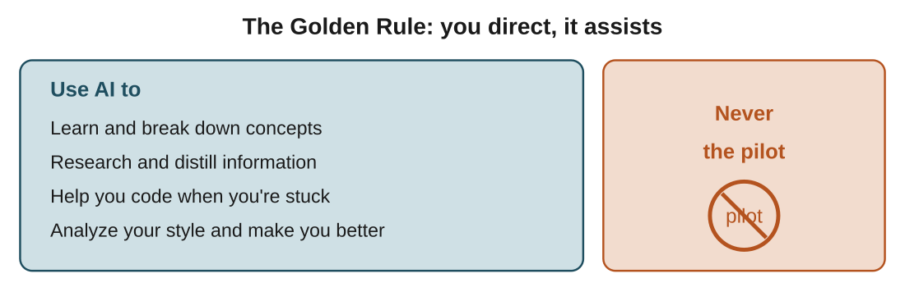
Figure 6: four green lights and one hard red line. Everything AI does for you sits under "you direct".
In the real world: Need authentication? Don't hand-roll password hashing and session logic. A maintained open-source library already handles the edge cases you haven't thought of yet. Use it as leverage and spend your time on what is actually yours.

6. What makes a programmer great now
In one line: Once AI can generate code, "great" is defined by the things AI can't own for you.
Key points
- You solve problems, not just write code. The code is the medium, and the value is the problem solved.
- You have judgment. You know which tool, structure, or approach fits, and why.
- You think like an owner. You connect your work to the product and the business, and design experiments that create value.
- You understand what you ship. You can explain and defend every line, whoever typed it.
- You communicate and document. Work that no one can see or trust doesn't compound.
- Syntax is cheap now. Judgment, ownership and imagination are the moat.
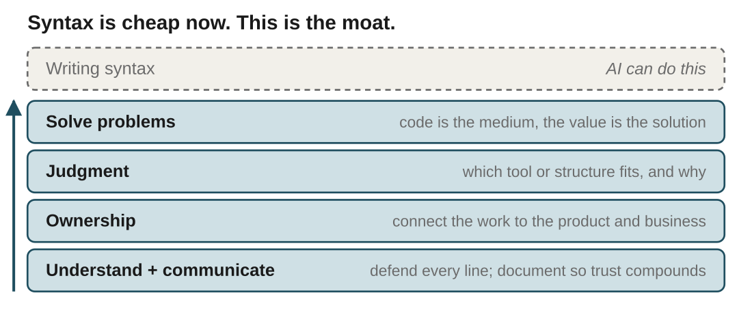
Figure 7: the faded top is what AI absorbed. Everything below it is why we learn the fundamentals deeply.
Watch out: We don't learn fundamentals to out-type a machine. We learn them to build the judgment that lets us direct the machine. That is the whole point of the course.

7. How the web works: the players
In one line: A URL locates a resource, and a chain of players fetches it and hands it back.
Think of it like: Picture a dairy farm with lots of orders. Customers order (the client), an ops team routes each order (DNS), the farm assembles the product (the server), and the warehouse stores the goods (the database).
Key points
- URL (Uniform Resource Locator). The name says it: it locates a specific resource, whether a page, an image, or a video.
- Client. Your browser and you, the one who wants something.
- DNS (Domain Name System). The phonebook of the internet. It translates scaler.com into an IP address that points to a machine.
- Server. A program, not a place, that receives your request and prepares a response by following a set of rules.
- Database. The warehouse where the actual data lives.
- A server is not a database. The server is the worker that fetches from the database and sends it back.
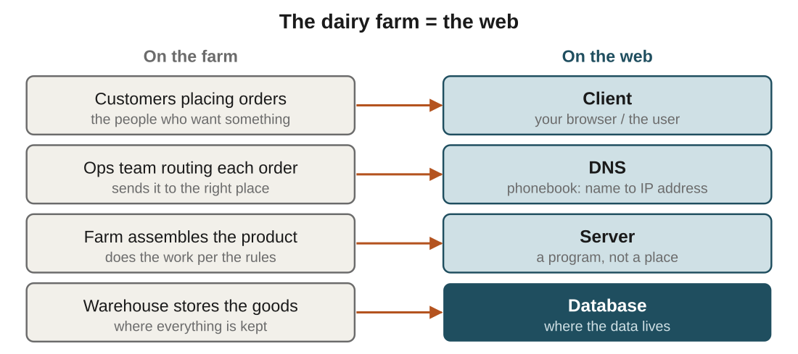
Figure 8: every player on the web has a farm counterpart. If you can run the farm, you can debug the web.
In the real world: You type scaler.com. DNS is the ops team that knows scaler.com actually lives at a specific IP, the same way a phonebook turns a name into a number.
Watch out: "Server" trips people up. It is a running program, not a physical box in a room, and the same machine can run many servers at once. Nobody keeps a server in a shoe box under the desk, tempting as that sounds.

8. The request-response cycle & HTTP
In one line: Client and server talk over HTTP in a fixed request-then-response dance.
Think of it like: HTTP is the agreed format of the order slip. Without shared rules for how an order is written, the farm couldn't understand what you asked for.
Key points
- The browser has two jobs: send your request, then render the response into the page you see.
- Step 1. You enter a URL, and the browser asks DNS for the server's IP.
- Step 2. The browser sends an HTTP request to that server.
- Step 3. The server processes it, fetching from the database if needed.
- Step 4. The server sends back an HTTP response, usually HTML, CSS and JS, or data.
- Step 5. The browser renders it into the page you see.
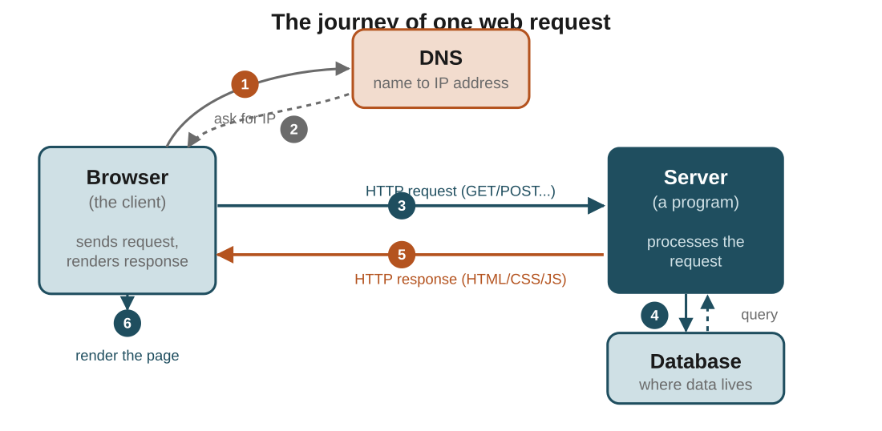
Figure 9: one request, start to finish. Follow the numbers. Teal is the request going out, orange is the response coming back.
In the real world: Loading your profile page: the browser GETs /profile, the server queries the database for your details, it responds 200 OK with HTML, and the browser renders it. Delete your account and the browser sends a DELETE instead.
Terms to know
- HTTP: HyperText Transfer Protocol, the shared language of client and server
- Methods: GET to fetch data, POST to send data, PUT to update, DELETE to remove
- Status codes: what happened: 200 OK, 404 Not Found, 500 Server Error
Watch out: You don't need to memorise every status code today. The goal is to picture the journey of a request, because you can't debug a system you can't picture.

Quick recap
- Prompting isn't programming. Your edge over non-coders is understanding the design and every line.
- Sensei mode: use AI to learn deeply and go down rabbit holes, not to get answers handed to you.
- Become an owner. AI does the distillation now, so value shifts to product sense, experiments, documentation and visibility.
- Function-generator mode: small, DRY, testable functions keep you in control, easy to debug and cheaper on tokens.
- The Golden Rule: use AI to learn, research and unblock, but never make it the pilot.
- A great programmer wins on judgment, ownership and imagination, not syntax.
- The web is a request-response journey. Client to DNS to server to database, spoken over HTTP, rendered by the browser.

Try it yourself
- Write your own sensei prompt and save it. Use it the next time you are tempted to paste in a problem and copy the answer.
- This week, run one small experiment with AI, give it a pass/fail metric, and write down the result in one paragraph.
- Take a feature you are building and list it as separate DRY functions, each with a sample input and expected output, before asking AI to generate any of them.
- From memory, draw the request-response cycle. Label the client, DNS, server and database, and mark where HTTP is spoken.

